

** Please show all work on separate paper and attach – no credit will be given for solutions that are missing work **

This Study Test is to be completed as preparation for the Unit Test and will be graded as a section of this test.

You are encouraged to use all available resources such as class notes, HW assignments, and the textbook.

Collaboration with classmates is not permitted and copying work is considered cheating and will result in a zero.

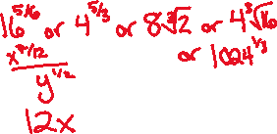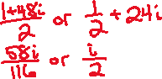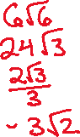

1. _________________
2. _________________
3. _________________
4. _________________
5. _________________
6. _________________
7. _________________
8. _________________
9. _________________
10. _________________
11. _________________
12. _________________
13. _________________
14. _________________
15. _________________
16. _________________
17. *x* = ______________
18. *x* = ______________
19. *x* = ______________
20. *x* = ______________
21. Fully simplify the radical expression: 
22. Fully simplify the radical expression: 
23. Fully simplify the radical expression: 
24. Fully simplify the radical expression: 
25. Write the complex number in standard form: 
26. Write the complex number in standard form: 
27. Fully simplify the expression: 
28. Fully simplify the expression: 
29. Fully simplify the expression: 
30. Fully simplify the expression: 
31. Fully simplify the expression: 
32. Fully simplify the expression: 
33. Fully simplify the expression: 
34. Fully simplify the expression: 
35. Calculate the inverse of the equation: 
36. Calculate the inverse of the equation: 
37. Solve the equation for all values of *x*: 
38. Solve the equation for all values of *x*: 
39. Solve the equation for all values of *x*: 
40. Solve the equation for all values of *x*: 